Zambia and Why to Avoid Angry Giraffe’s- by Jamin Smitchger

In celebration of the International Year of Pulses as declared by the United Nations Food and Agriculture Organization, I was one of ten graduate students the Crop Science Society of America and USAID sent to Zambia to increase international knowledge of grain legumes. The UN designation aims to heighten public awareness of the nutritional benefits of pulses as part of sustainable food production. The idea is to promote pulse-based proteins, further global production of pulses, better crop rotations, and address the challenges in the trade of pulses. Grain legumes are increasing in importance in Africa because they are a high quality source of protein, which is desperately lacking in the developing world.

The Pan African Grain Legume Conference, which was sponsored by organizations such as USAID, The Bill and Melinda Gates Foundation, CIAT, ICRISAT, and many other smaller NGO’s, was the largest grain legume conference in Africa to date. The energy and enthusiasm of researchers from all over the globe could be clearly felt. I met many people who are the brains of the pro grain legume movement in Africa, and I really got a feel for the flavor of the African culture. While the conference was specific to Africa, I did learn a good bit about the dozens of grain legumes grown in Africa, and it is likely that we could grow a number of these legume crops in Montana. For example, researchers at Texas A&M have developed a black-eyed pea (cowpea) variety that matures in just 60 days. Some fast-maturing grain legume crops that are adapted to areas south of the Sahara Desert can live with just 7 inches of annual rainfall. It would be interesting to see what makes those crops so drought tolerant.

I was warned that traveling to Africa was dangerous, and I thought I understood the risks. After all, Africa contains the world’s most dangerous animal, the anopheles mosquito, which kills nearly a million people each year, and I was vaccinated against various diseases that were endemic in Africa. Unfortunately, nobody warned me that GIRAFFES are dangerous and should be avoided at all costs. You can view my violent encounter here <https://www.youtube.com/watch?v=WQBc5gVExmU>, complete with me running for my life. Although I should have known better, I was confident in my knowledge that giraffes are vegetarian, which just goes to show you that book-larnin only goes so far. However, how many people on earth can say that they were ever attacked by a giraffe?!!!

I was also able to see the famous Victoria Falls, which is one of the seven natural wonders of the world, and I went on a 3 hour safari after the conference was finished. I saw water buffaloes, giraffes, a hippo, impala, waterbucks, warthogs, and rhinos. The rhinos are comfortable being around humans because they are guarded 24/7 by 7 rangers with AK-47’s in order to prevent poaching. I was able to get within 30 feet of the rhinos without alarming them, shockingly close.

Africa is a special place, with its own unique set of challenges. Currently 1 out of every 10 people in Zambia are living with HIV/AIDS, the average life expectancy is 53 years, malnutrition is rampant, and the average annual income is 1200 US dollars. Poverty is apparent anytime you venture into the city or countryside. There are many researchers in Africa who understand the problems Africa faces, and they are determined to do things about them. It was heartening to see the passion of African researchers, many who were trained in the United States, and it is apparent that the solutions Africa needs rest securely in their hands. Here in the United States we need to do our best to support these scientists. The future of Africa greatly depends on it.

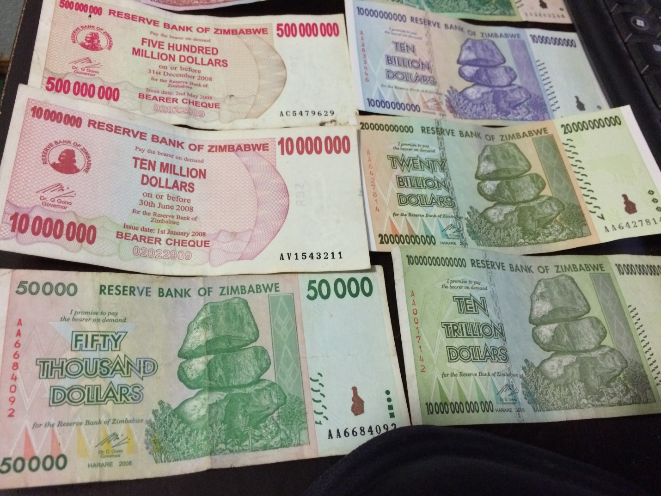

”.

The Bank of Zimbabwe holds notoriety for being the bank that printed the quadrillion dollar note due to runaway inflation. The notes are completely worthless except for the lesson they provide in regard to monetary policy.

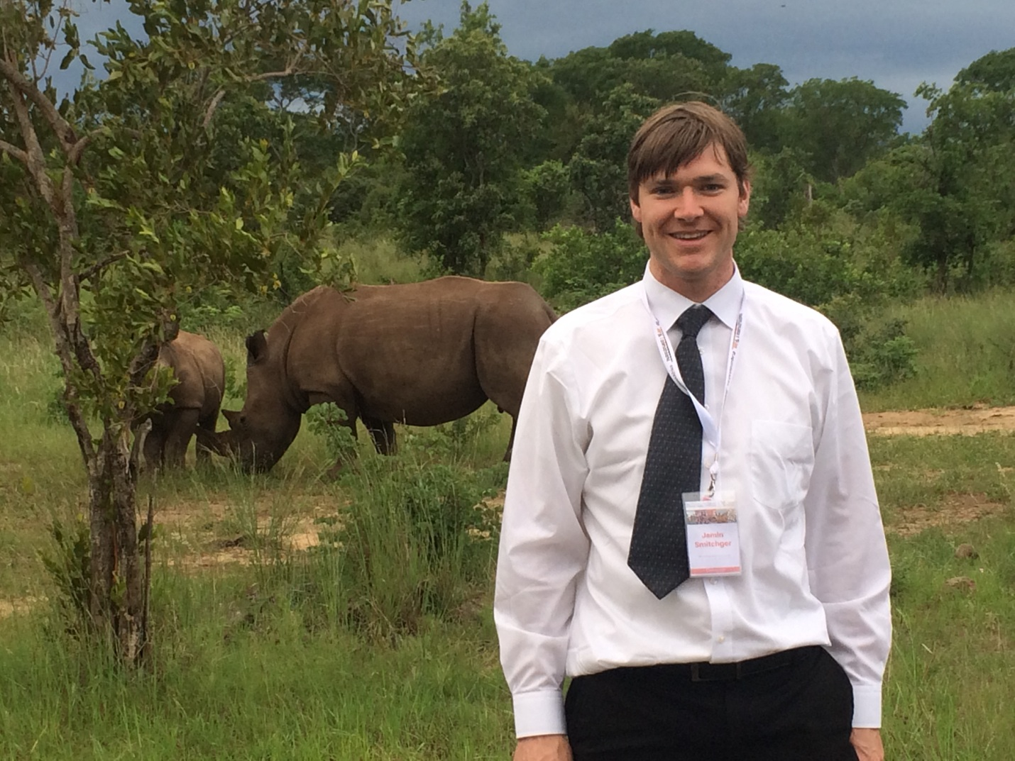

Wide-mouthed Rhinos.

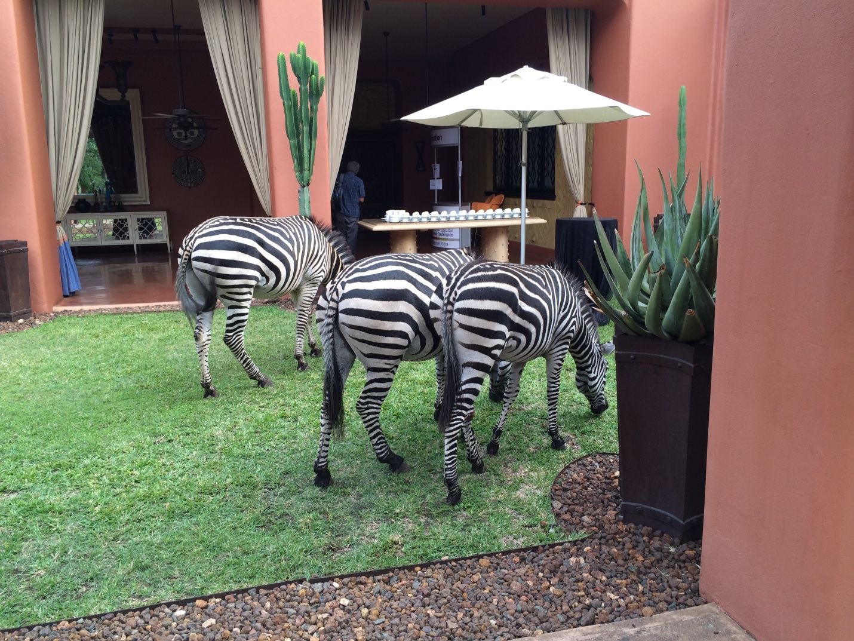

Zebras grazing in the African Bush.

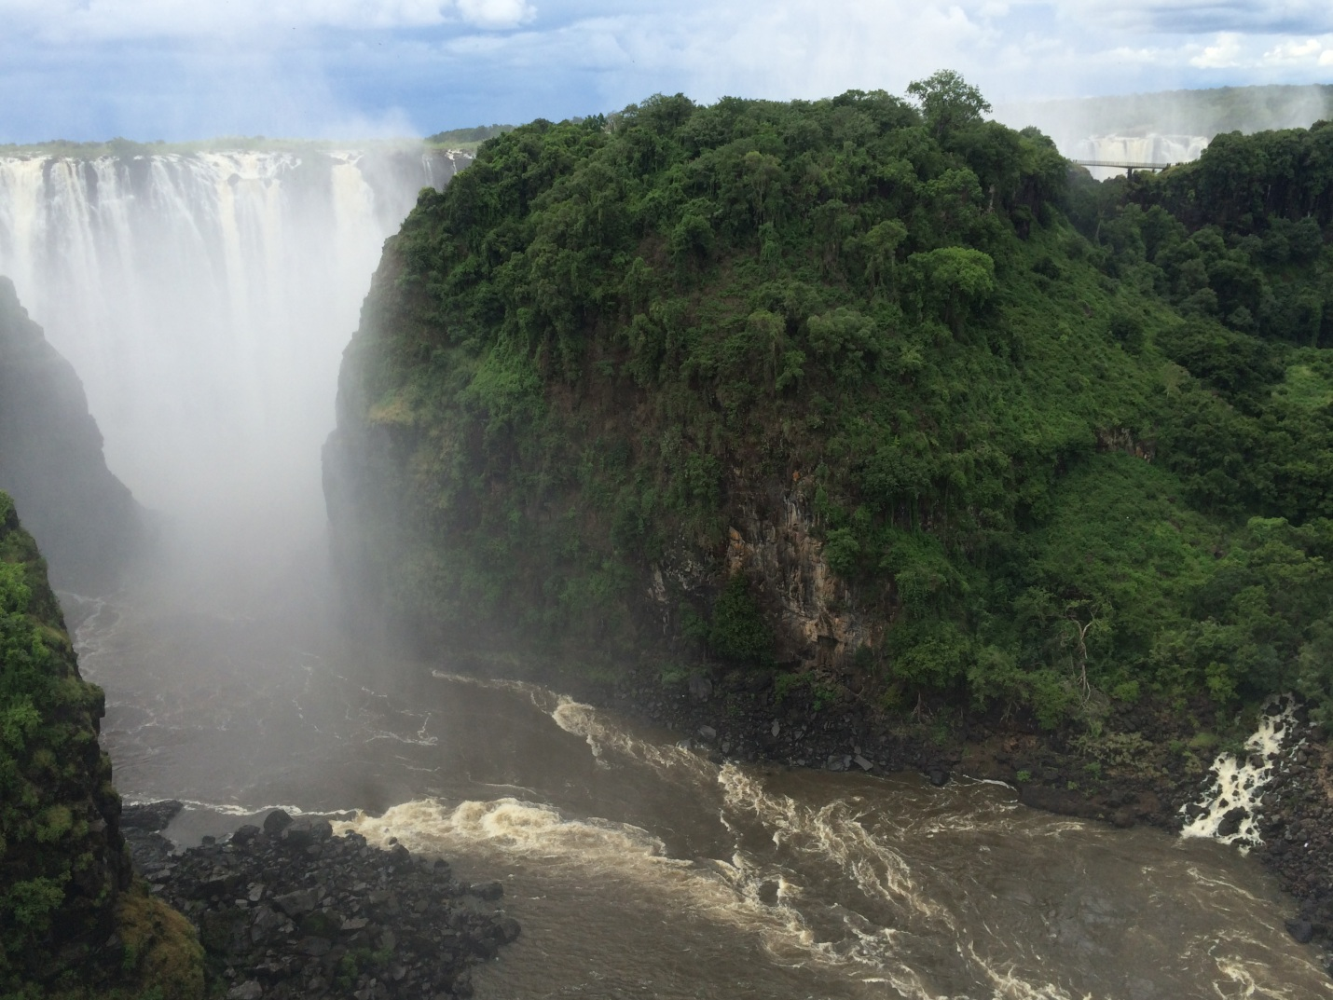

Victoria Falls (Note that the actual breadth of the falls is actually wider than this picture)

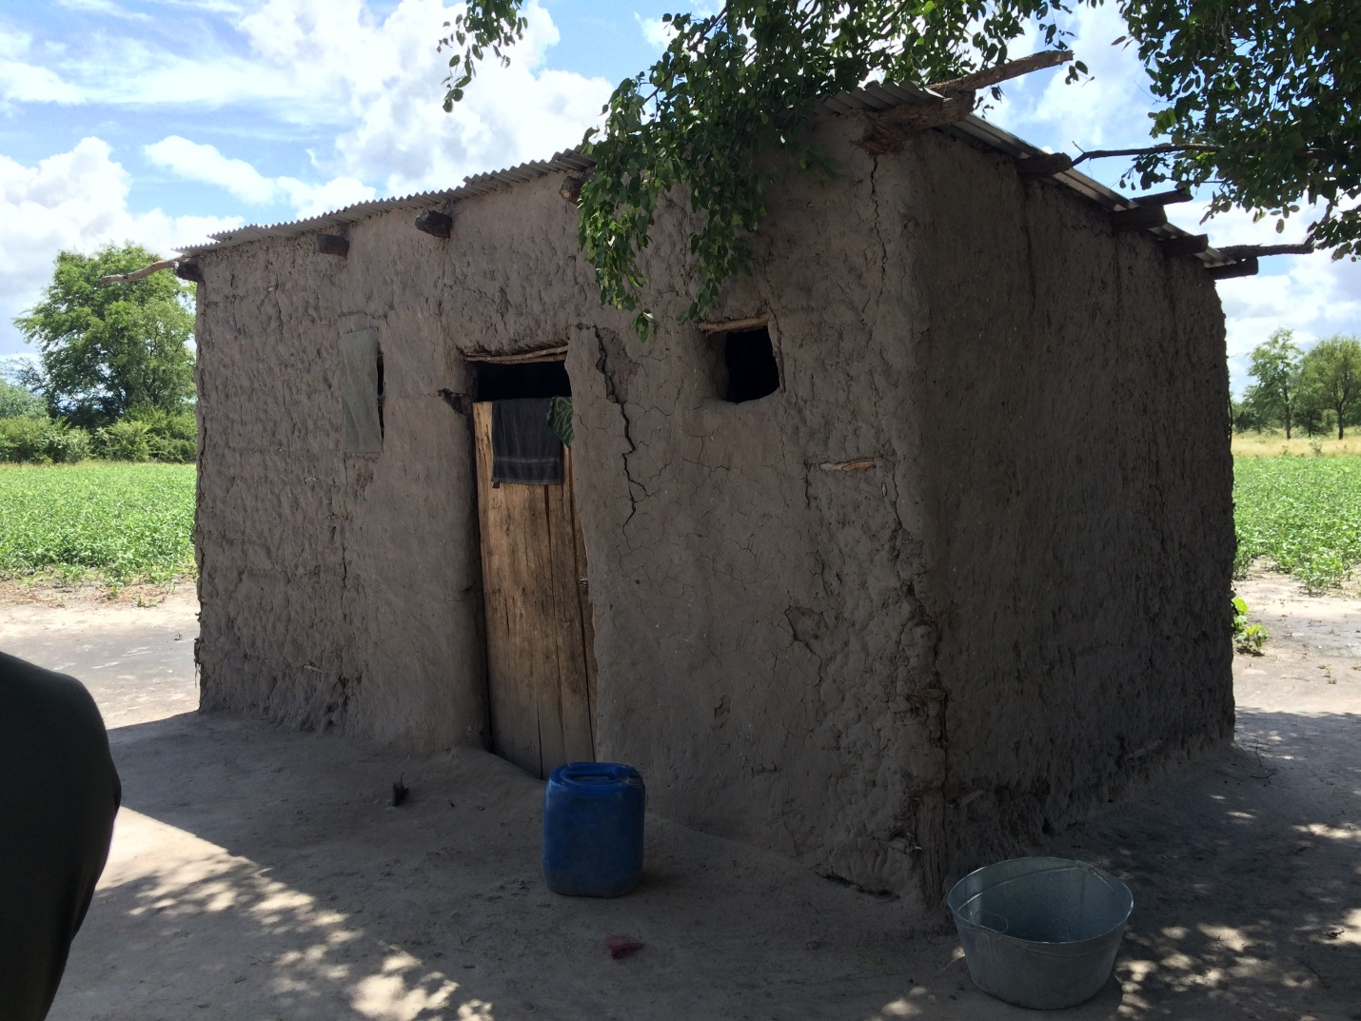

One of the nicer mud huts in Kalingula Village.

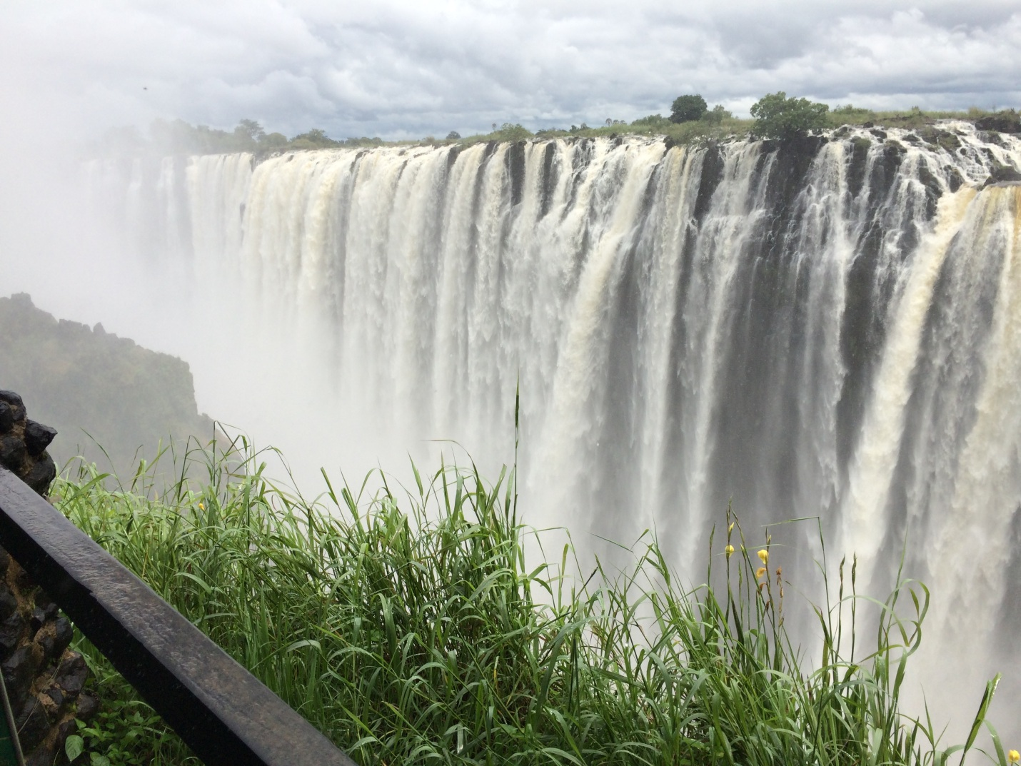

Part of Victoria Falls (One of the seven natural wonders of the world.)

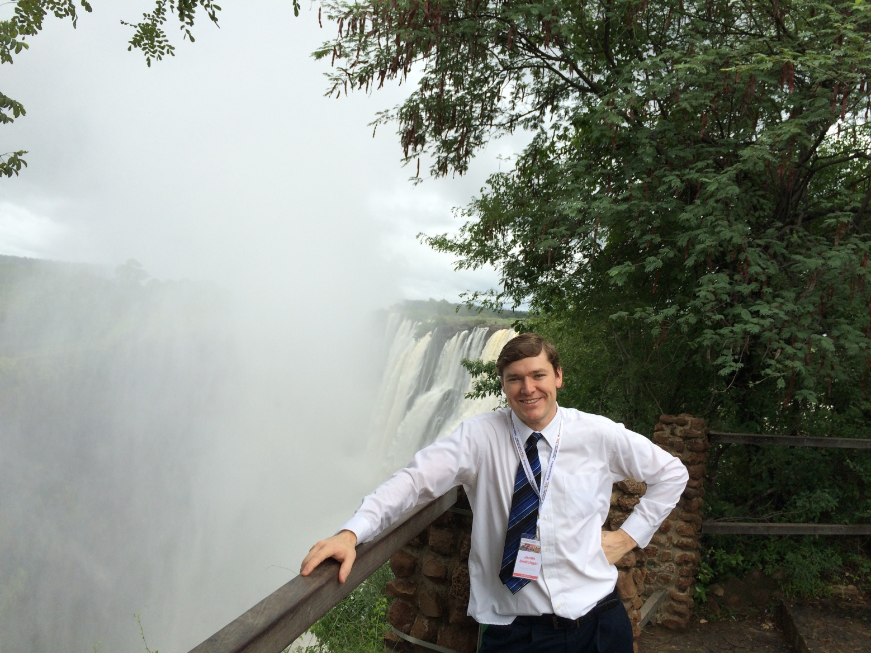

I would say that Zambia is one of the most beautiful places on earth, but someone might find a fallacy in that argument.